Can a Little Stimulation improve ATDPC-based Cardiovascular Repair Strategies?

March 13, 2017
Review of “Electromechanical Conditioning of Adult Progenitor Cells Improves Recovery of Cardiac Function after Myocardial Infarction” from Stem Cells Translational Medicine by Stuart P. Atkinson
The normal function of the developing and adult heart submits cardiac cells to mechanical and electrical forces, both of which appear to be crucial for proper cell functionality. However, cell-based strategies for the treatment of cardiovascular disorders rarely employ electrical and mechanical stimulation and, therefore, transplanted cells may present with inherent functional deficits.
To counter this problem, researchers from the laboratory of Antoni Bayes-Genis (Germans Trias i Pujol University Hospital, Barcelona, Spain) recently described an optimized protocol for the electromechanical stimulation of neonatal rat cardiac cells [1]. The team now return with a new Stem Cells Translational Medicine study reporting on how the transplantation of electromechanically stimulated human adipose tissue-derived progenitor cells of cardiac origin (cardiac ATDPCs) [2, 3] may represent an effective means to boost heart repair following myocardial infarction [4].
So, can a little “stimulation” improve ATDPC-based cardiovascular repair strategies?
In short, yes! The study chose cardiac ATDPCs given their ease of isolation and cultivation, their cardiac and endothelial differentiation potential, and previous encouraging in vivo studies [2, 3]. In vitro, electromechanical stimulation promoted an upregulation of cardiac, key structural, and calcium handling genes as compared to both unstimulated cardiac ATDPCs and stimulated subcutaneous ATDPCs, suggestive of a greater reparative potential.
Indeed, analysis of infarcted mouse hearts following the implantation of stimulated cardiac ATDPCs (as part of an engineered 3D fibrin patch) demonstrated that transplanted cells expressed major cardiac markers, migrated into the underlying ischemic myocardium, and boosted vessel density in the infarct border region. Together, these advantageous consequences mediated a 12% increase in cardiac function relative to non-treated animals.
While electromechanical stimulation provides obvious benefits, at the current level of development, the ATDPC growth and stimulation apparatus (See Figure) limits the number of transplantable cells. However, future scaling up of this technology may provide sufficient cell numbers to make the jump to preclinical testing and clinical application of ATDPC-based cardiovascular repair strategies.
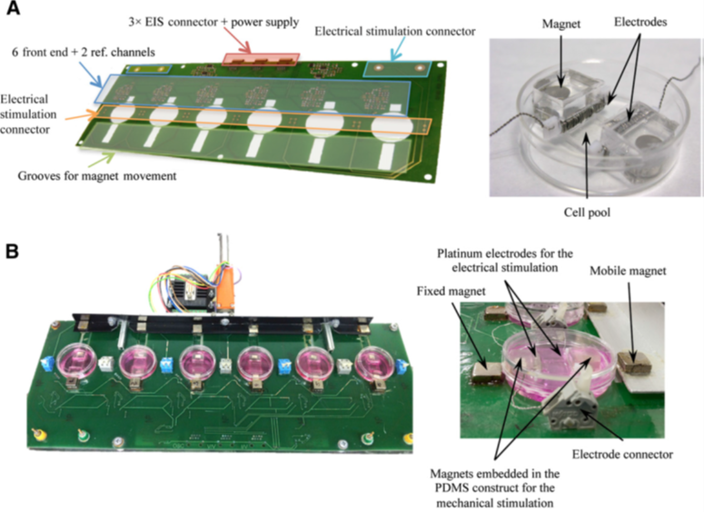
References
- Godier-Furnemont AF, Tiburcy M, Wagner E, et al. Physiologic force-frequency response in engineered heart muscle by electromechanical stimulation. Biomaterials 2015;60:82-91.
- Bayes-Genis A, Soler-Botija C, Farre J, et al. Human progenitor cells derived from cardiac adipose tissue ameliorate myocardial infarction in rodents. J Mol Cell Cardiol 2010;49:771-780.
- Bago JR, Soler-Botija C, Casani L, et al. Bioluminescence imaging of cardiomyogenic and vascular differentiation of cardiac and subcutaneous adipose tissue-derived progenitor cells in fibrin patches in a myocardium infarct model. Int J Cardiol 2013;169:288-295.
- Llucià-Valldeperas A, Soler-Botija C, Gálvez-Montón C, et al. Electromechanical Conditioning of Adult Progenitor Cells Improves Recovery of Cardiac Function After Myocardial Infarction. STEM CELLS Translational Medicine 2017;6:970-981.

